UNIVERSITY OF WAH (UOW)

DEPARTMENT OF COMPUTER SCIENCE



BSCS 3RD B

REG #: UW-24-CS-BS-088

SUBMITTED BY: SAADI SAFDAR

SUBMITTED TO: Ms. MUNNIBA KHAN

COURSE TITLE: DATA STRUCTURES

COURSE CODE: CS – 201 L

LAB REPORT # 5

Assigned tasks in lab.

1. Matrix Multiplication using 2D Arrays
#include <iostream>
using namespace std;
int main()
{
int r1, c1, r2, c2;
cout << "Enter rows and columns for first matrix: ";
cin >> r1 >> c1;
cout << "Enter rows and columns for second matrix: ";
cin >> r2 >> c2;
if (c1 != r2)
{
cout << "Matrix multiplication not possible!" << endl;
return 0;
}
int A[10][10], B[10][10], C[10][10] = {0};
cout << "Enter elements of first matrix:" << endl;
for (int i = 0; i < r1; i++)
{
for (int j = 0; j < c1; j++)
{
cin >> A[i][j];
}
}
cout << "Enter elements of second matrix:" << endl;
for (int i = 0; i < r2; i++)
{
for (int j = 0; j < c2; j++)
{
cin >> B[i][j];
}
}
for (int i = 0; i < r1; i++)
{
for (int j = 0; j < c2; j++)
{
for (int k = 0; k < c1; k++)
{
C[i][j] += A[i][k] * B[k][j];
}
}
}
cout << "Resultant matrix after multiplication:" << endl;
for (int i = 0; i < r1; i++)
{
for (int j = 0; j < c2; j++)
{
cout << C[i][j] << " ";
}cout << endl;
}return 0;
}
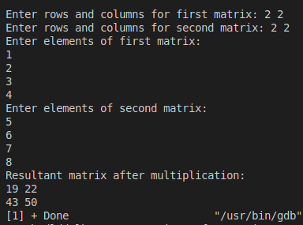

2. Swapping Values using Pointers
#include <iostream>
using namespace std;
int main()
{
int a = 10;
int b = 8;
cout << "Enter two numbers for a & b: ";
cin >> a >> b;
int *ptr1 = &a;
int *ptr2 = &b;
int temp;
temp = *ptr1;
*ptr1 = *ptr2;
*ptr2 = temp;
cout << "After swapping: a = " << a << " & b = " << b << endl;
}

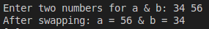
3. Dynamic Memory Allocation using Pointers
#include <iostream>
using namespace std;
int main() {
int size;
cout << "Enter size of array: ";
cin >> size;
int *arr = new int[size];
cout << "Enter " << size << " elements: ";
for (int i = 0; i < size; i++)
cin >> *(arr + i);
cout << "Array elements are: ";
for (int i = 0; i < size; i++)
cout << *(arr + i) << " ";
delete[] arr;
return 0;
}

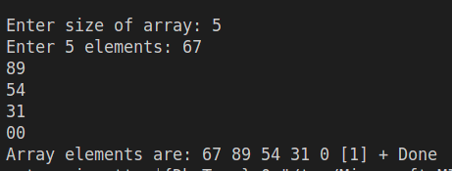

4. Void Pointer
#include <iostream>
using namespace std;
int main() {
float value = 12.5;
void *ptr = &value;
cout << "Address of float variable: " << &value << endl;
cout << "Address stored in void pointer: " << ptr << endl;
cout << "Value using typecasting: " << *(float*)ptr << endl;
return 0;
}
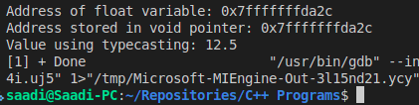

5. Structure within Structure
#include <iostream>
using namespace std;
struct Roll {
char dep[10];
int session;
int regNo;
char degree[10];
};
struct Student {
char name[20];
int age;
struct Roll rn;
};
int main() {
Student s1;
cout << "Enter name: ";
cin >> s1.name;
cout << "Enter age: ";
cin >> s1.age;
cout << "Enter department: ";
cin >> s1.rn.dep;
cout << "Enter session: ";
cin >> s1.rn.session;
cout << "Enter registration number: ";
cin >> s1.rn.regNo;
cout << "Enter degree: ";
cin >> s1.rn.degree;
cout << "\n----- Student Record ------\n";
cout << "Name: " << s1.name << endl;
cout << "Age: " << s1.age << endl;
cout << "Department: " << s1.rn.dep << endl;
cout << "Session: " << s1.rn.session << endl;
cout << "Registration No: " << s1.rn.regNo << endl;
cout << "Degree: " << s1.rn.degree << endl;
return 0;
}

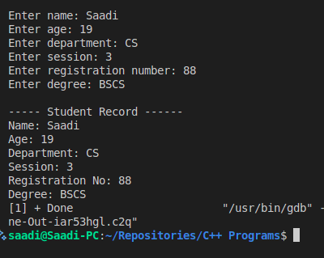

6. Sorting and Searching in Structure
#include <iostream>
#include <cstring>
using namespace std;
struct Employee {
char name[20];
int empID;
float salary;
};
int main() {
Employee emp[3];
cout << "Enter data for 3 employees:\n";
for (int i = 0; i < 3; i++) {
cout << "Name: ";
cin >> emp[i].name;
cout << "Emp ID: ";
cin >> emp[i].empID;
cout << "Salary: ";
cin >> emp[i].salary;
}
for (int i = 0; i < 3 - 1; i++) {
for (int j = 0; j < 3 - i - 1; j++) {
if (emp[j].salary < emp[j + 1].salary) {
Employee temp = emp[j];
emp[j] = emp[j + 1];
emp[j + 1] = temp;
}
}
}
cout << "Employees sorted by salary:\n";
for (int i = 0; i < 3; i++) {
cout << emp[i].name << " (ID: " << emp[i].empID << ") Salary: " << emp[i].salary << endl;
}
char searchName[20];
cout << "Enter name to search: ";
cin >> searchName;
bool found = false;
for (int i = 0; i < 3; i++) {
if (strcmp(emp[i].name, searchName) == 0) {
cout << "Record found:\n";
cout << "Name: " << emp[i].name << "\nID: " << emp[i].empID << "\nSalary: " << emp[i].salary << endl;
found = true;
break;
}
}
if (!found) {
cout << "Employee not found." << endl;
}
return 0;
}

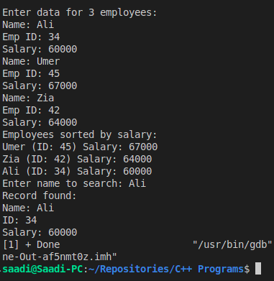

7. Lab Task
Task 7: Mini Student Record System (Final Lab Task)
Objective: Integrate all concepts.
Assignment:
• Create an array of 5 students using nested structures.
• Each student has: name, age, roll (with department, session, registration, degree), and 3
subject marks.
• Compute average GPA for each student.
• Sort students by GPA (highest first).
• Search a student by registration number and display full record.

#include <iostream>
using namespace std;
struct Roll {
char department[20];
int session;
int registration;
char degree[10];
};
struct Student {
char name[50];
int age;
Roll roll;
float marks[3];
float gpa;
};
int main() {
const int NUM_STUDENTS = 5;
Student students[NUM_STUDENTS];
cout << "--- Enter Data for " << NUM_STUDENTS << " Students ---" << endl;
for (int i = 0; i < NUM_STUDENTS; i++) {
cout << "\n--- Student " << i + 1 << " ---" << endl;
cout << "Name: ";
cin >> students[i].name;
cout << "Age: ";
cin >> students[i].age;
cout << "Department: ";
cin >> students[i].roll.department;
cout << "Session (e.g., 2025): ";
cin >> students[i].roll.session;
cout << "Registration No: ";
cin >> students[i].roll.registration;
cout << "Degree (e.g., BS): ";
cin >> students[i].roll.degree;
cout << "Enter 3 subject marks (separated by space): ";
cin >> students[i].marks[0] >> students[i].marks[1] >> students[i].marks[2];
students[i].gpa = (students[i].marks[0] + students[i].marks[1] + students[i].marks[2]) / 3.0f;
}
for (int i = 0; i < NUM_STUDENTS - 1; i++) {
for (int j = 0; j < NUM_STUDENTS - i - 1; j++) {
if (students[j].gpa < students[j + 1].gpa) {
Student temp = students[j];
students[j] = students[j + 1];
students[j + 1] = temp;
}
}
}
cout << "\n--- Students Sorted by GPA (Highest First) ---" << endl;
for (int i = 0; i < NUM_STUDENTS; i++) {
cout << "Rank " << i + 1 << ": " << students[i].name
<< "\t(Reg No: " << students[i].roll.registration
<< ", GPA: " << students[i].gpa << ")" << endl;
}
int searchReg;
cout << "\n--- Search Student by Registration Number ---" << endl;
cout << "Enter Registration Number to search: ";
cin >> searchReg;
bool found = false;
for (int i = 0; i < NUM_STUDENTS; i++) {
if (students[i].roll.registration == searchReg) {
cout << "\n--- Record Found ---" << endl;
cout << "Name: " << students[i].name << endl;
cout << "Age: " << students[i].age << endl;
cout << "Department: " << students[i].roll.department << endl;
cout << "Session: " << students[i].roll.session << endl;
cout << "Registration No: " << students[i].roll.registration << endl;
cout << "Degree: " << students[i].roll.degree << endl;
cout << "Marks: " << students[i].marks[0] << ", "
<< students[i].marks[1] << ", " << students[i].marks[2] << endl;
cout << "GPA: " << students[i].gpa << endl;
found = true;
break;
}
}
if (!found) {
cout << "Student with Registration No " << searchReg << " not found." << endl;
}
return 0;
}

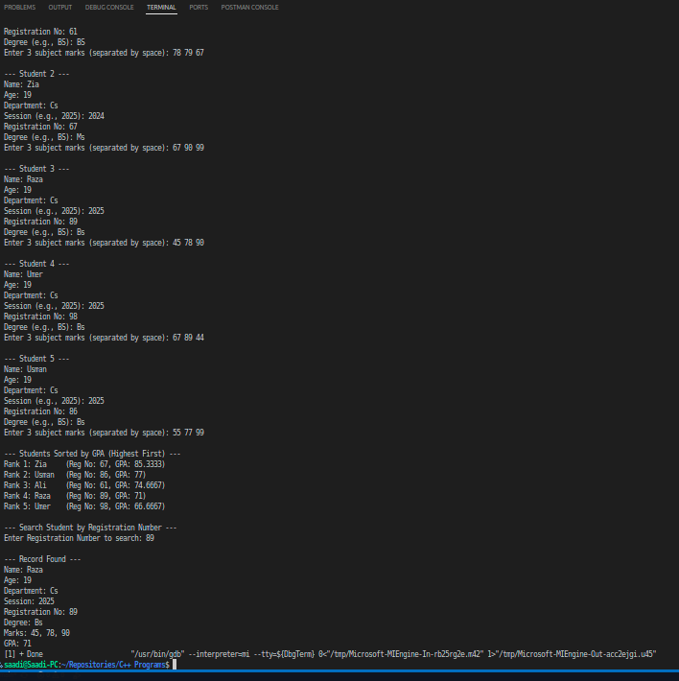
--- OTHERS ---
Searching and Sorting in Structure

#include <iostream>
#include <cstring>
using namespace std;
struct Employee {
char name[20];
float salary;
};
int main() {
Employee emp[3] = { {"Ali", 50000}, {"Sara", 60000}, {"Omar",
45000} };
// Linear Search
for (int i = 0; i < 3; i++) {
if (strcmp(emp[i].name, "Ali") == 0)
cout << "Found " << emp[i].name << " with salary " <<
emp[i].salary << endl;
}
// Bubble Sort by salary (descending)
for (int i = 0; i < 3; i++) {
for (int j = 0; j < 2; j++) {
if (emp[j].salary < emp[j + 1].salary)
swap(emp[j], emp[j + 1]);
}
}
cout << "\nEmployees sorted by salary:\n";
for (int i = 0; i < 3; i++)
cout << emp[i].name << " - " << emp[i].salary << endl;
return 0;
}
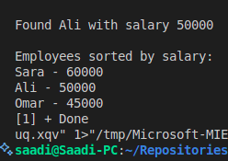

Searching
#include <iostream>
using namespace std;
int main()
{
int arr[] = {2, 4, 6, 8, 10, 12, 14,};
int n = 7;
int key, low = 0, high = n - 1, mid;
cout << "Enter the element to be searched: ";
cin >> key;
while (low <= high)
{
mid = (low + high) / 2;
if (arr[mid] == key)
{
cout << "Element found at index " << mid << endl;
return 0;
}
else if (key < arr[mid])
{
high = mid - 1;
}
else
{
low = mid + 1;
}
}
cout << "Element not found in the array" << endl;
return 0;
}
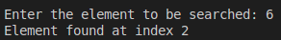

Sorting
#include <iostream>
using namespace std;
int main()
{
int arr[5] = {3, 1, 5, 4, 2};
int n = 5;
for(int i = 0; i < n - 1; i++)
{
for(int j = 0; j < n - i - 1; j++)
{
if(arr[j] > arr[j + 1])
{
swap(arr[j], arr[j + 1]);
}}}
cout << "Sorted array: ";
for(int i = 0; i < n; i++)
{
cout << arr[i] << " ";
}cout << endl;
return 0;}

